Bin Chen

Charlotte Mei

MSEI 606

Professor Patrick T. O’Regan

7/7/2020

Vebture Website Launched Report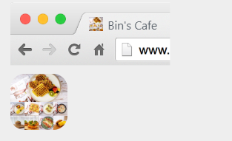

Bin’s cafe website address: <http://ivw.rek.mybluehost.me/>

You will see our site icon, site title and tagline, when you search our website.

Our website is mobile friendly, so that our customers can check the menu and make reservation directly from their cell phone.

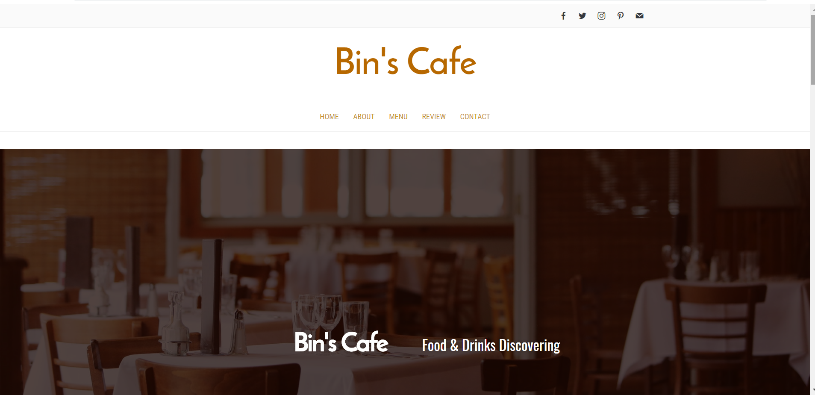

Totally we have five pages on our website, which is home, about, menu, review and contact page. As you can see, there are five social media icons on the right top of the homepage. In the future, our customer can check our cafe info by social media as well.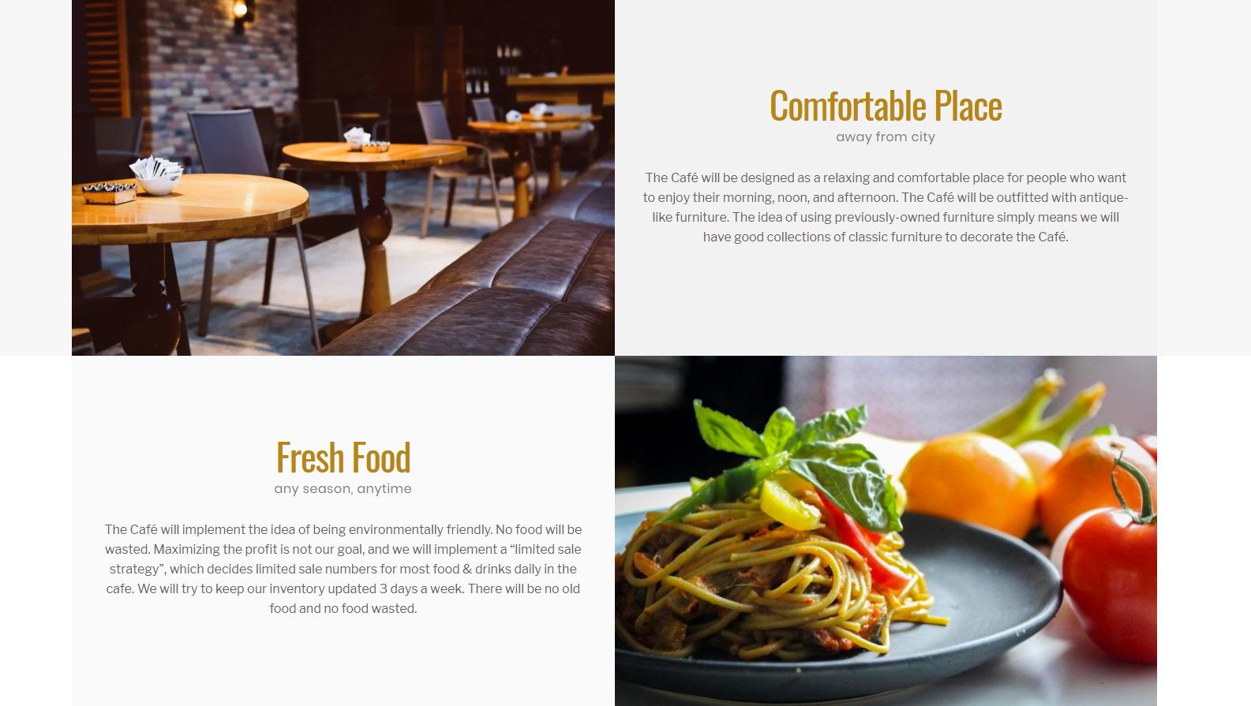

**Home page**

Our home page list all the reasons that customers should visit our cafe.

1.comfortable place - The Café will be designed as a relaxing and comfortable place for people who want to enjoy their morning, noon, and afternoon. The Café will be outfitted with antique-like furniture. The idea of using previously-owned furniture simply means we will have good collections of classic furniture to decorate the Café.

2. Fresh food- The Café will implement the idea of being environmentally friendly. No food will be wasted. Maximizing the profit is not our goal, and we will implement a “limited sale strategy”, which decides limited sale numbers for most food & drinks daily in the cafe. We will try to keep our inventory updated 3 days a week. There will be no old food and no food wasted.

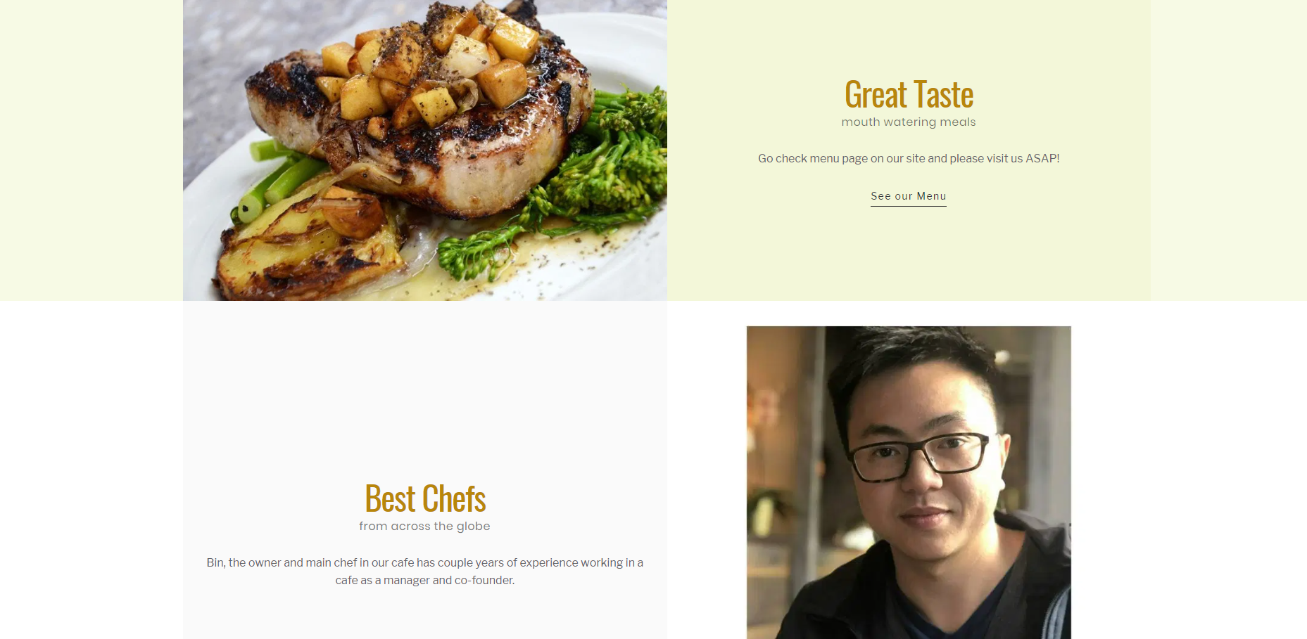

**Home page**

**3.** Great Taste

4. Best Chefs

5. Love by all the customers.

At the bottom of our homepage have our cafe’s info such as cafe address and opening hours. (check the last screenshot of this page.)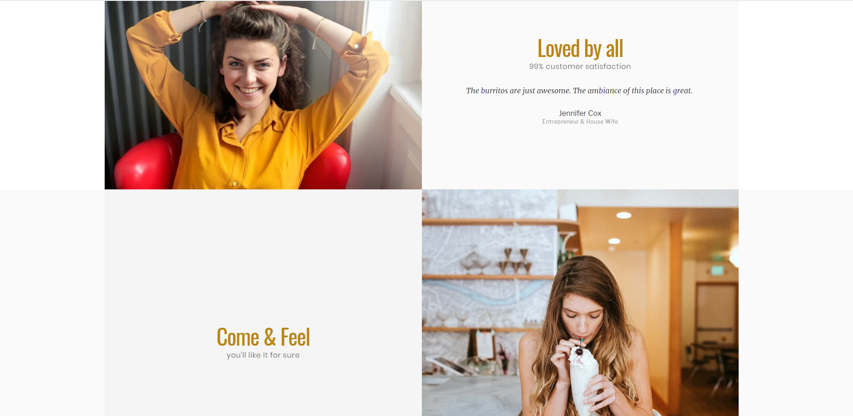

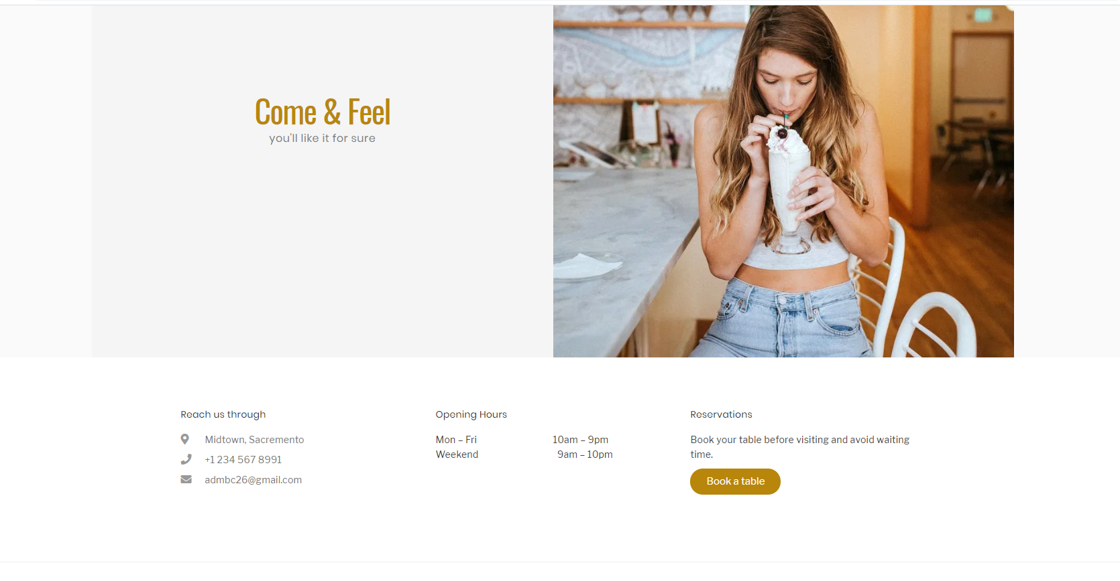

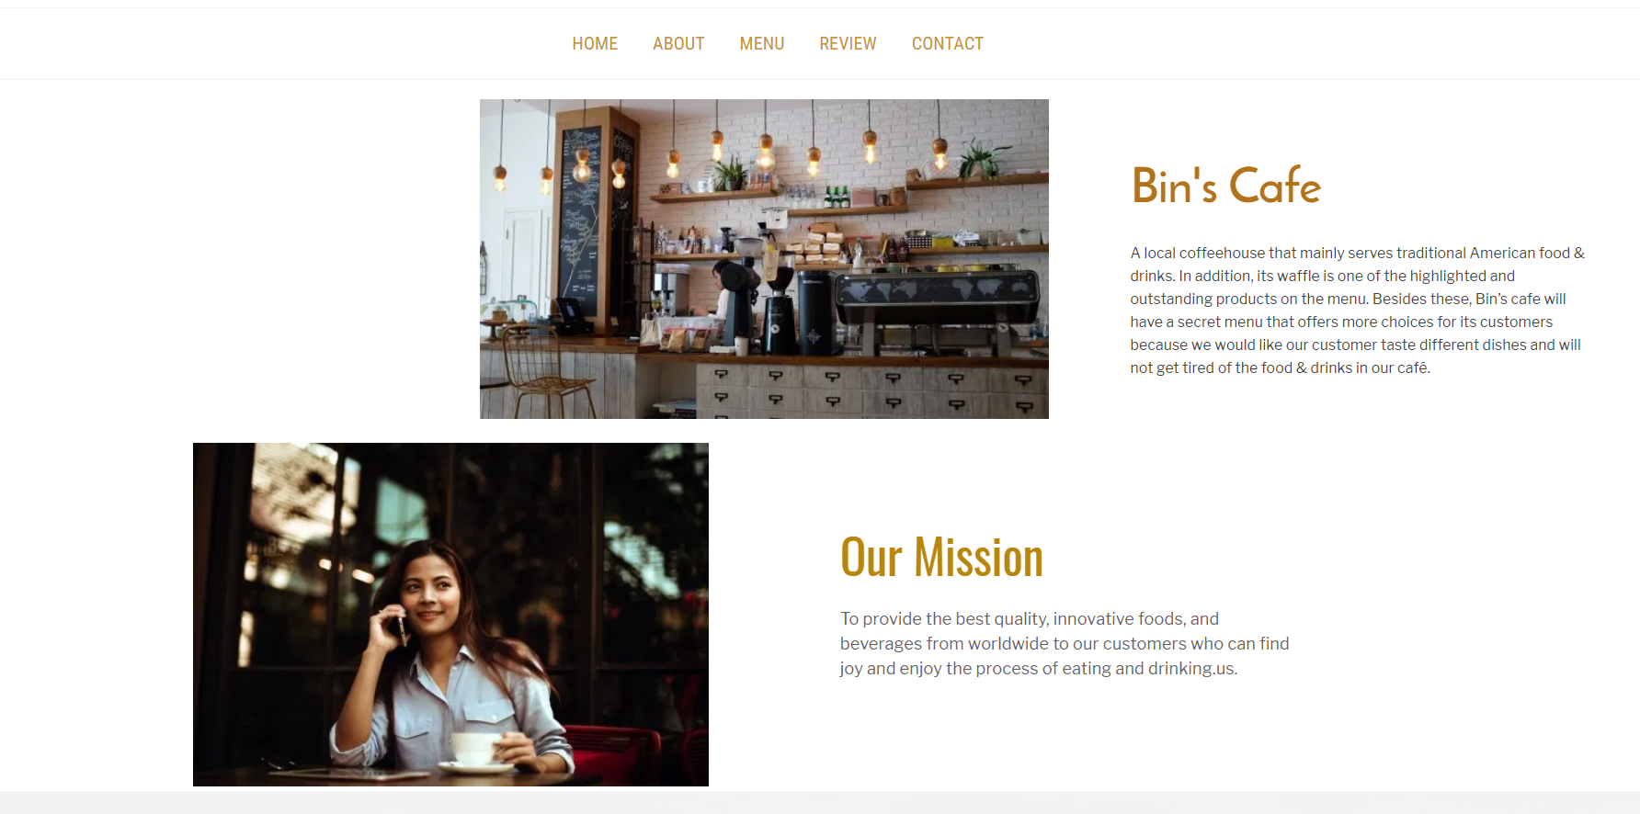

**About**

On the about page, we have Bin’s cafe story, mission, and team profile.

Bin’s cafe - A local coffeehouse that mainly serves traditional American food & drinks. In addition, its waffle is one of the highlighted and outstanding products on the menu. Besides these, Bin’s cafe will have a secret menu that offers more choices for its customers because we would like our customer taste different dishes and will not get tired of the food & drinks in our café.

Our Mission - To provide the best quality, innovative foods, and beverages from worldwide to our customers who can find joy and enjoy the process of eating and drinking.

Dedicated Team - We both have an interest in coffee and making traditional American food. Bin has a couple of years of experience working in a cafe as a manager and co-founder. Charlotte is a coffee lover. For the past few years, she has traveled to many places and tasted different kinds of coffee from local coffee shops. She has developed a union taste and skill of evaluating how a cup of good coffee is made. Also, she has a dream to become a coffee cupping who ensures the consistency of the coffee.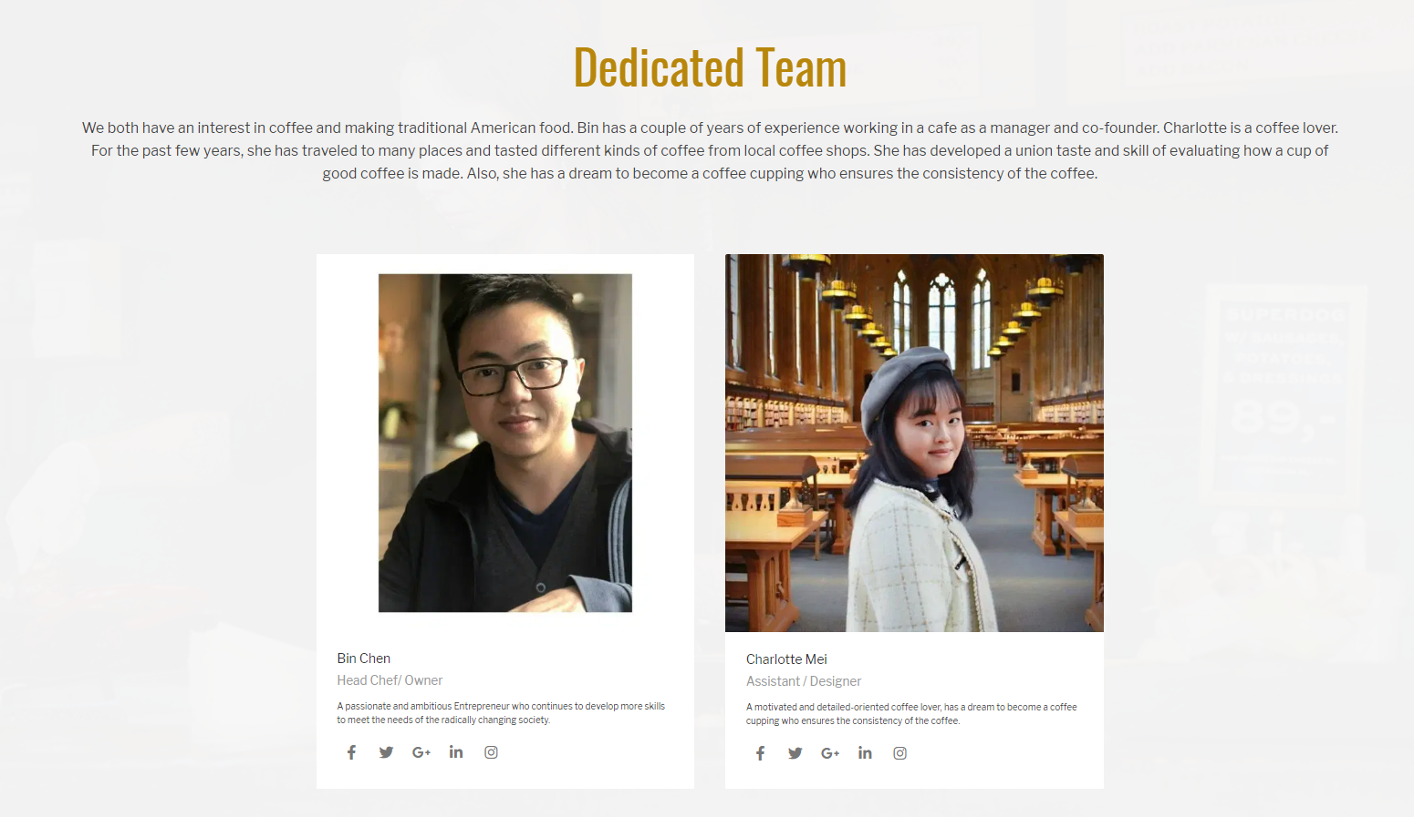

**Menu**

On the menu page, we list three of our popular dishes, boba and specialities.

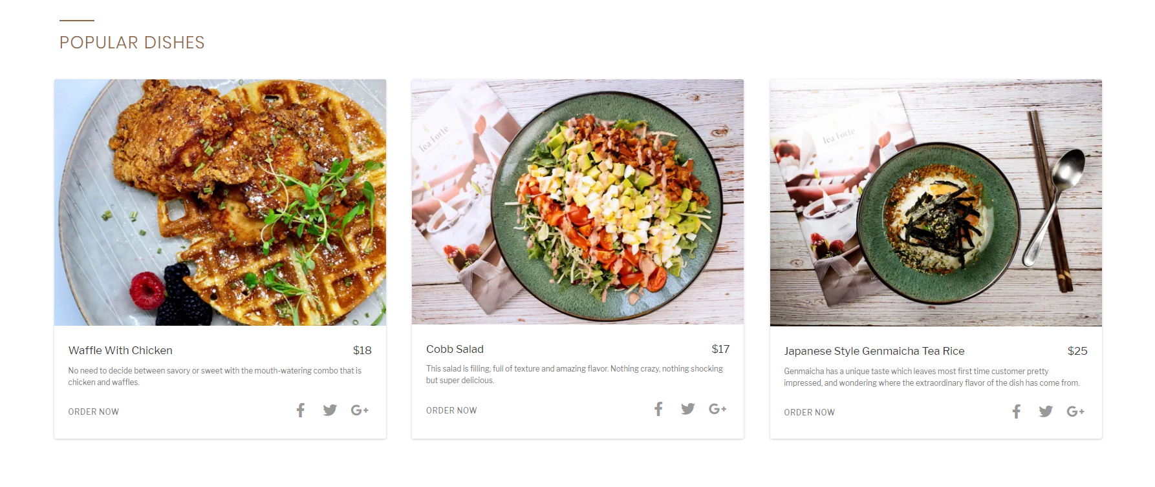

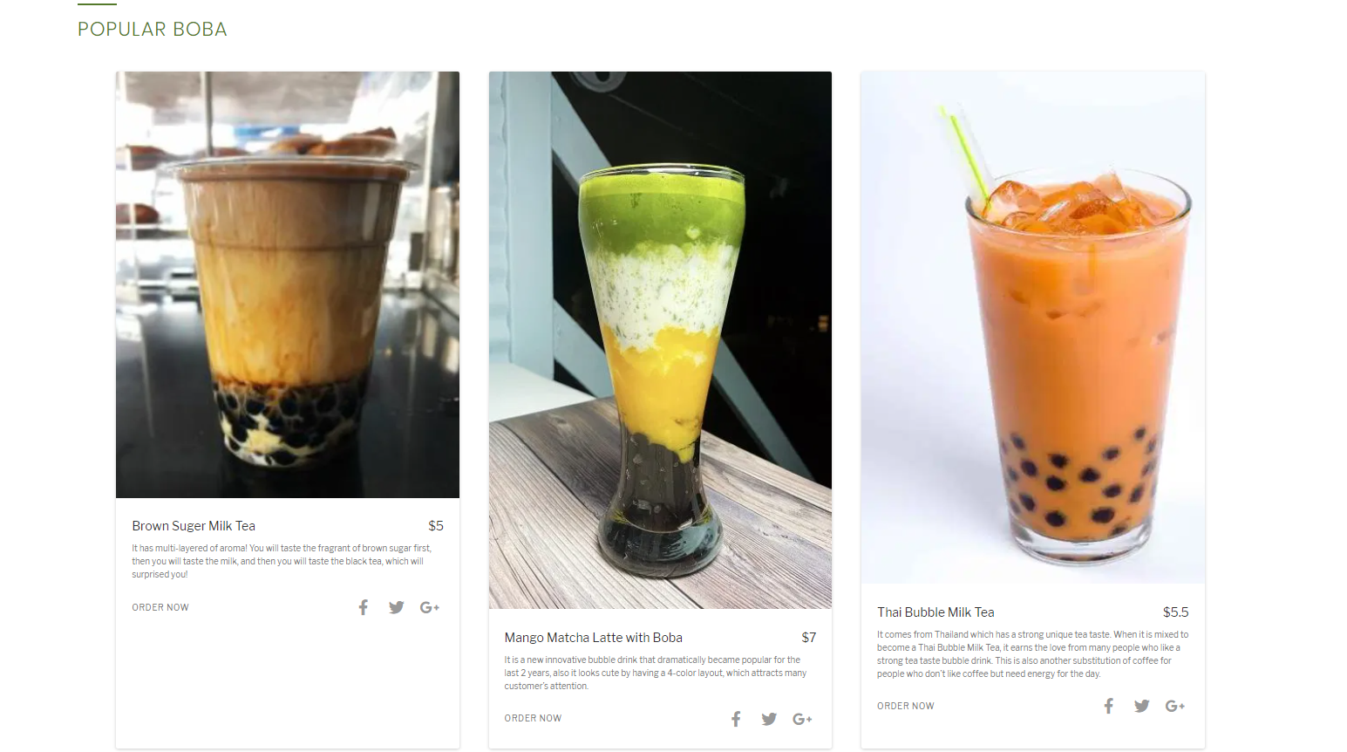

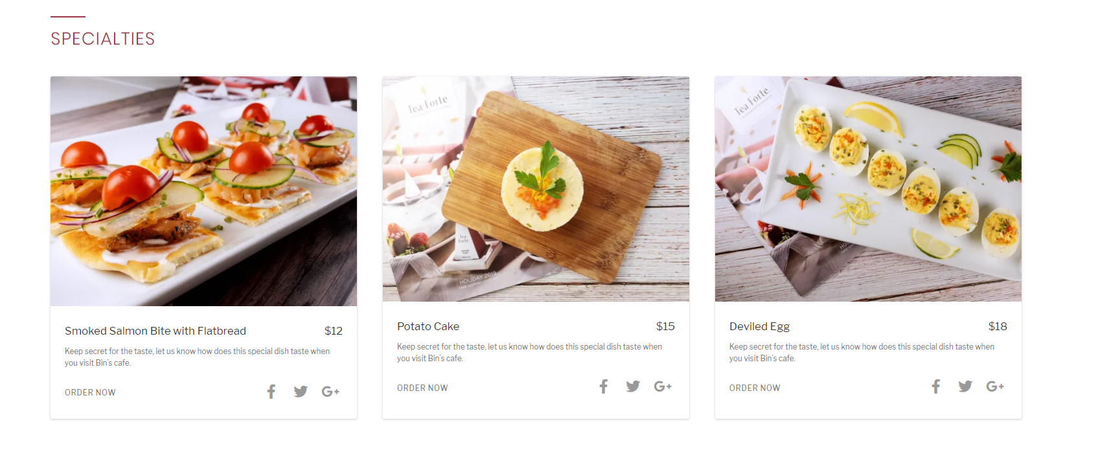

**Review**

As we learned from the course of Internet business, there are many befinitis of creating review pages on the website such as improved SEO positioning and boosted trust in the company’s product or service. Additionally, according to the study, “ Eight-in-ten Americans (82%) say they consult online ratings and reviews when buying something for the first time and nearly half of Americans feel that customer reviews help “a lot” to make consumers feel confident about their purchase.” Because of the above reasons, we create a review page on our website.

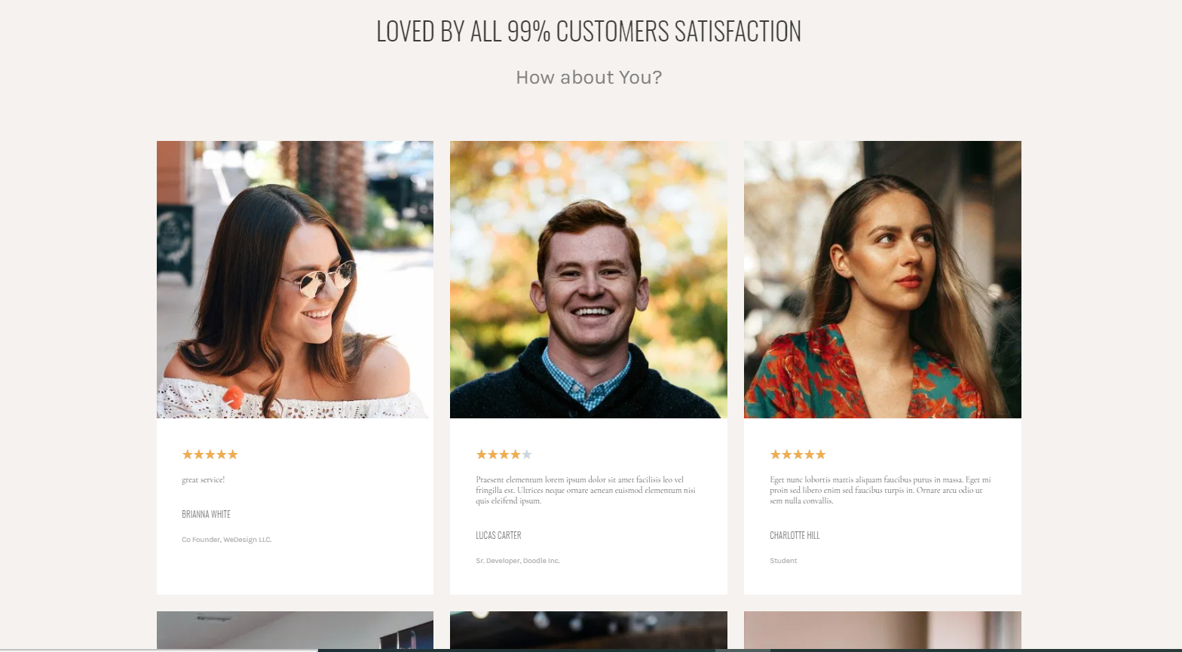

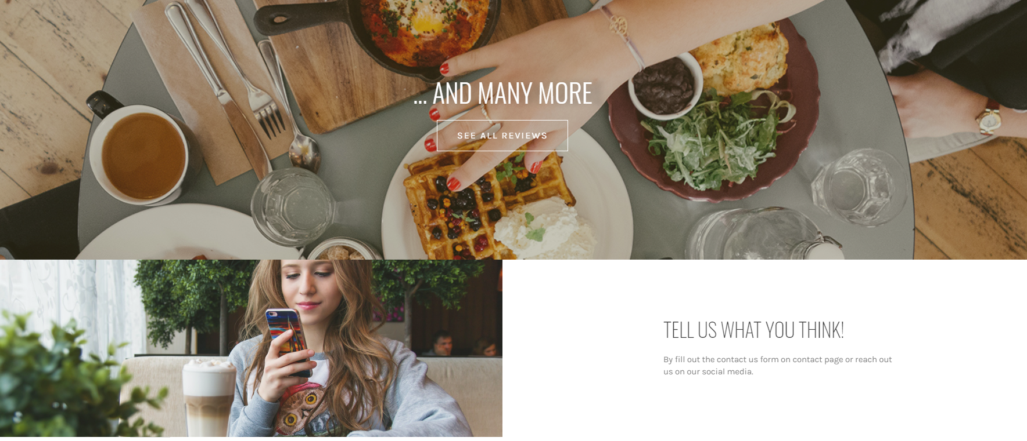

**Contact**

On the contact page, we have a contact us form. Our customer can fill out the form for reviewing our food or services or even sharing the photo that they took at our cafe. Also, on the contact page,we show our customers the location of our cafe by the goole map which our customer can easily check it from our website. Moreover, at the bottom of the page, we apply a “button- submit resume” which our future chefs and waiters can easily send their resume through our website.

